Asignment 4
Ujjwal Chowdhury

Assignmemt on regularised regression

Select a dataset from the UCI dataset on regression (exclude categorical ovaribales for now). First inspect the predictors for multicollinearity and select a subset which is linearly independent. Next find solution of linear regression model using normal equations and sequential gradient descent (Widrow Hoff ). Next fit a LASSO and Ridge model using scipy.optimize library. Plot the solution path for different values of α using "lassopath" and "ridgepath" libraries of scipy. Compare the three models in terms of the solution obtained, prediction accuracy etc. Interpret the Lasso and Ridge solutions in terms of selection and shrinkage. Upload two files - one code and one pdf with the brief report.

Report

Data Set :- I am using the Superconductivity Data Set from UCI.

Summary of the data :- I get the summary of the data using the .info function.

Filtering the data :- In this step I remove all other columns except the weighted columns.

Counting NA values:- In this step I check whether any NA values are inside any columns. In this case there is no NA value.

Multicollinearity :- Checking the correlation between each columns in the data frame using Heat map correlation matrix.
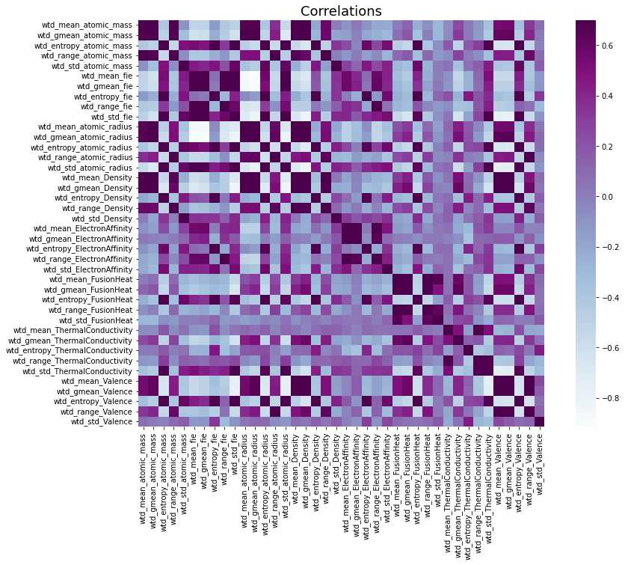
Selecting Features:- Here I have created a function which remove all highly correlated columns (threshold value = 0.6).
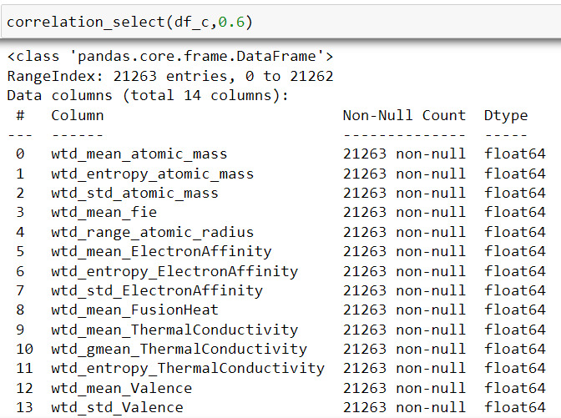

OLS:

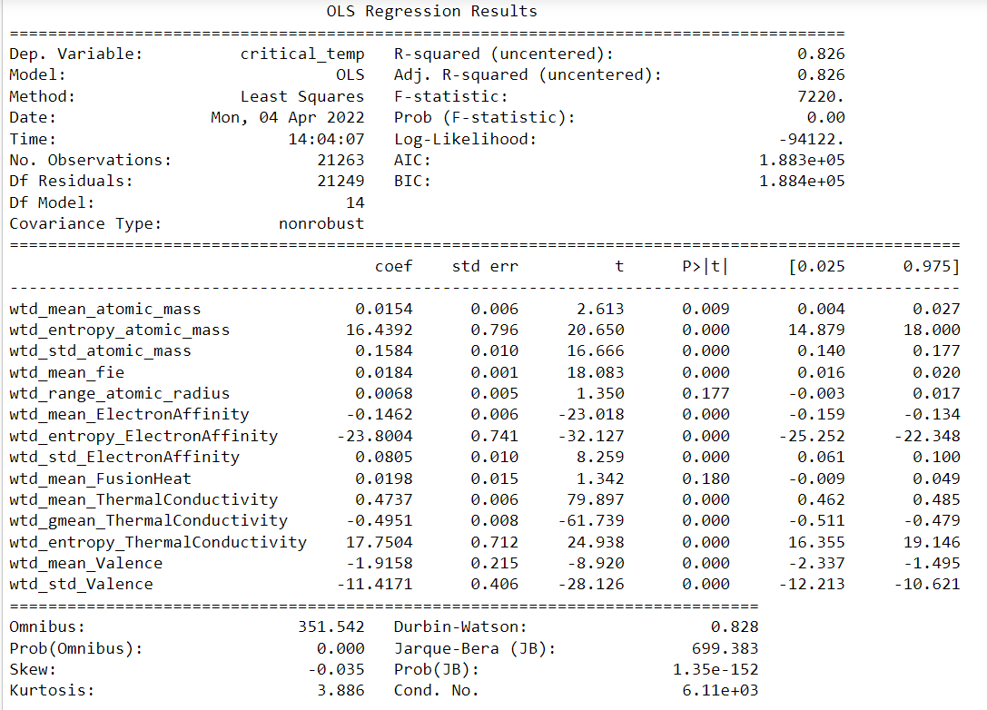

Batch Gradient Descent :-

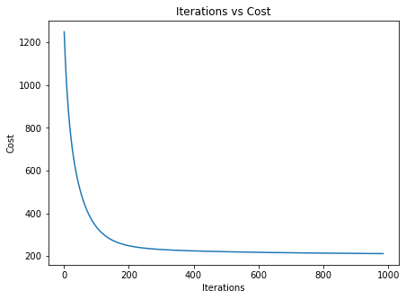
Total number of iterations = 984
Train Score: 0.41684103478349477
Test Score: 0.4286460967327166

Sequential Gradient Descent :-
Total number of iterations = 987 SGD coefficients
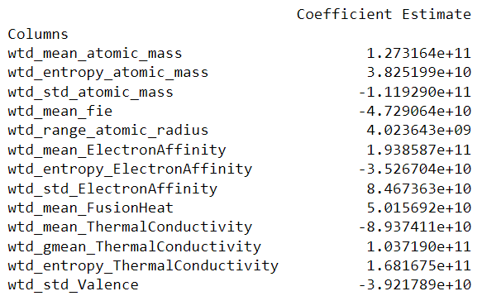
Train Score: 0.6430747438781501
Test Score: 0.6432614848770073
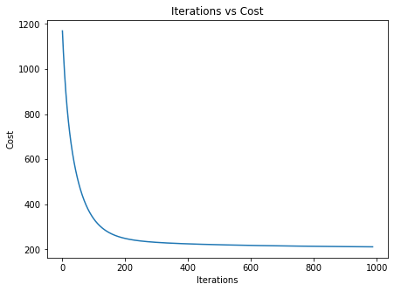

LASSO :-
LASSO coefficients
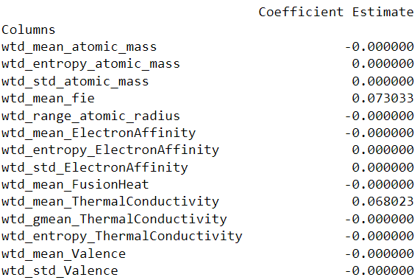
MSE training set 448.64022669539935
MSE test set 466.01888024885574

Accuracy of training set 0.6170671926145267
Accuracy of test set 0.6079409994390365

Ridge Regression :-

MSE of training set = 419.2101073342187 Coefficients estimates
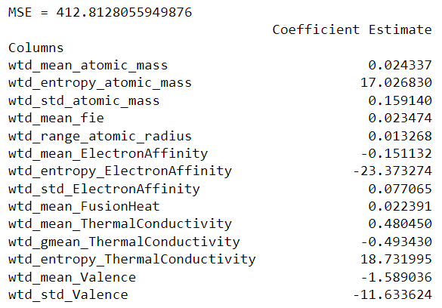
Accuracy of training set 0.6507528338821016
Accuracy of test set 0.6473209505616128

Elastic Net:-
Coefficients estimates
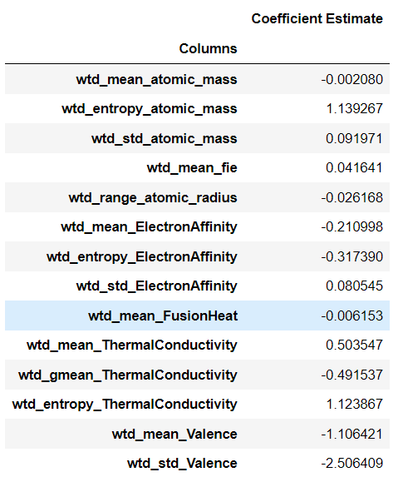
Accuracy of training set 0.6063905407734923
Accuracy of test set 0.5975760671689727

Observations :-
In LASSO regularization some coefficient values are becoming zero.

Plotting LASSO coefficients as a function of alpha

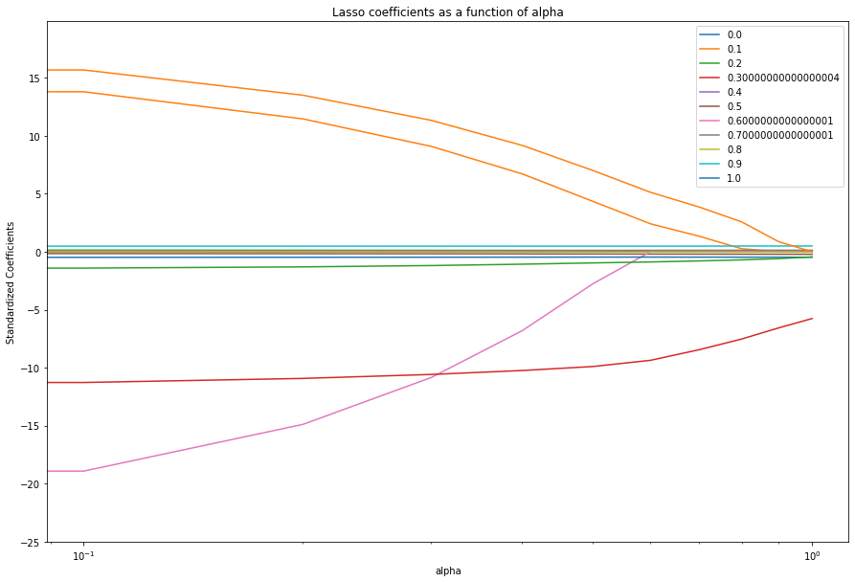

Comparing OLS & LASSO Coefficients:

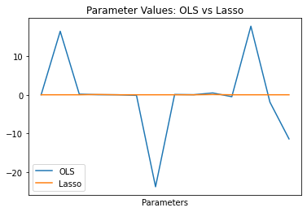
Comparing OLS & Ridge Coefficients:

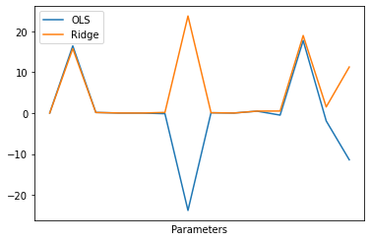

Comparing LASSO & Ridge Coefficients:

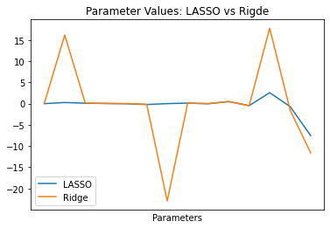

Comparing LASSO , Ridge and Elastic Net Coefficients:

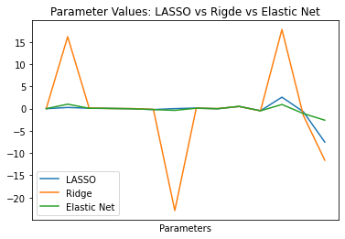

Comparing OLS , LASSO, Ridge,Elastic Net Coefficients:

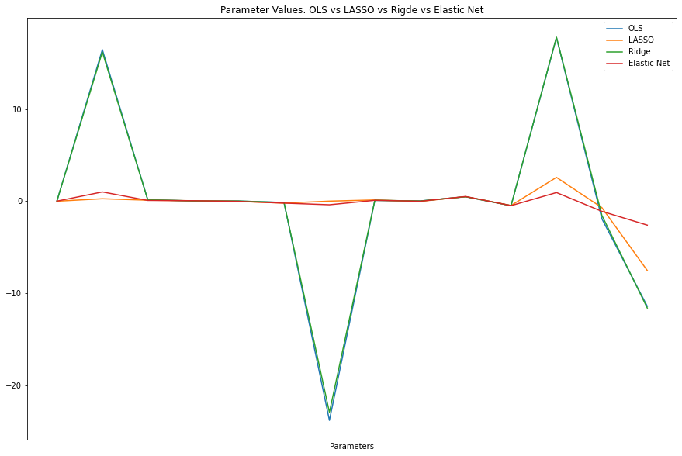

Comparing LASSO & Elastic Net Coefficients:

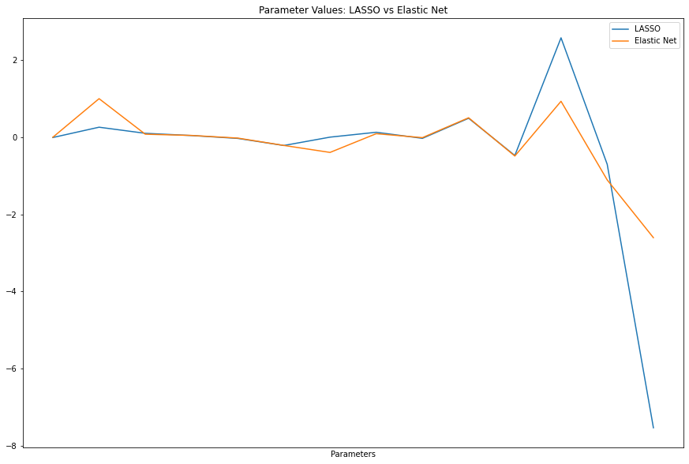

LASSO LRAS Paths: 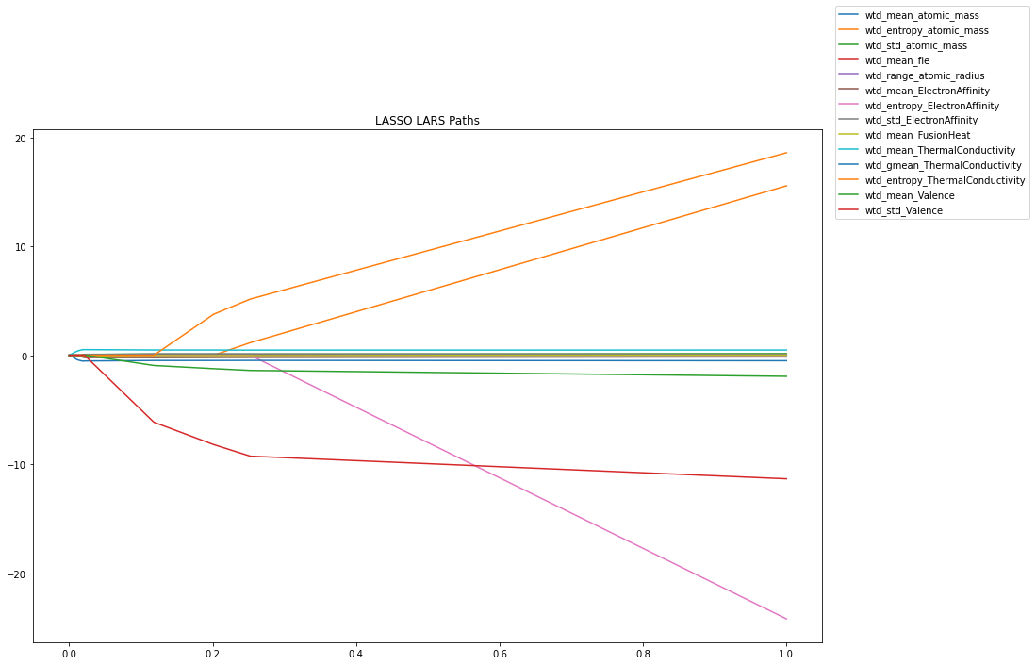

Ridge Paths:-
